**AI Based Discourse for Banking Industry**

|  |  |
| --- | --- |
| Date | 17 November 2022 |
| Team ID | PNT2022TMID15846 |
| Project Name | AI Based discourse for Banking Industry |
| Team Members | Sneha M  Swetha K  Yuvanthika S  Shree Lakshmi R |

**SPRINT-IV**

**Consolidated view of user bot interaction**

The user enters the text, based on the keyword the comparison is made and the respective action is triggered.

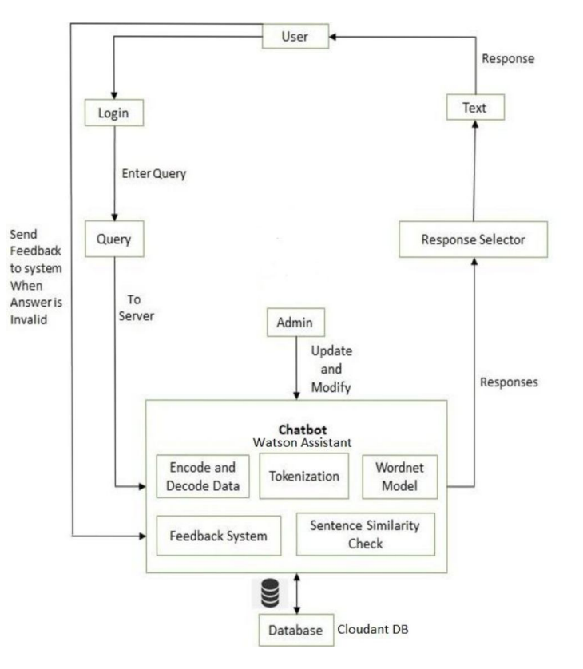

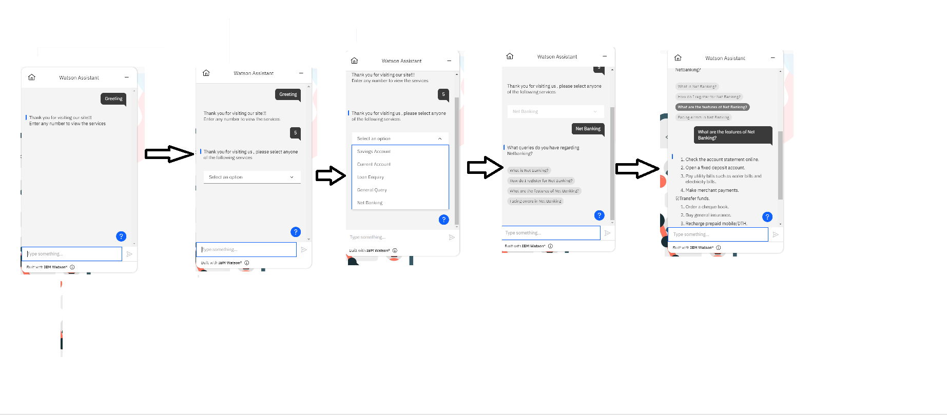

**User Acceptance testing:**



